Clear slicers.

You will need to control one slicer at the time. Select a slicer and click SLICER SETTINGS on the OPTIONS tab. In the code you will need to use the NAME TO USE IN FORMULAS:

You can find the code below for the two first slicers.

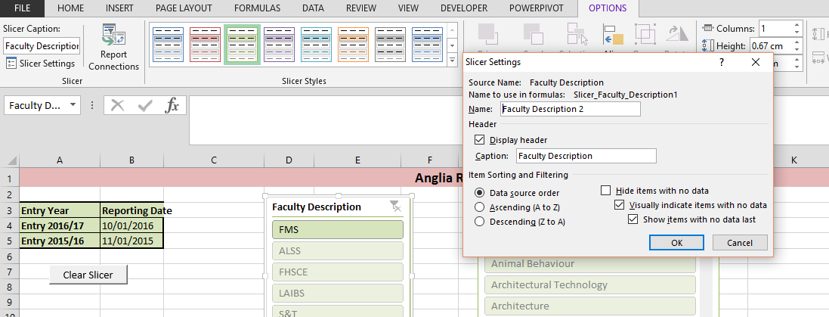

Sub ClearSlicer1()

ActiveWorkbook.SlicerCaches("slicer_Faculty_Description1").ClearManualFilter

ActiveWorkbook.SlicerCaches("slicer_course_Description1").ClearManualFilter

End Sub